GEOINT ASSESSMENT
Rocket Lab Launch Complex-1 (LC-1), Mahia Peninsula, New Zealand
Operational Capacity Evaluation
Mahia Peninsula, New Zealand

Assessment type | GEOINT assessment — operational capacity evaluation
Launch complex | Rocket Lab Launch Complex-1 (LC-1), Mahia Peninsula, New Zealand
Launch vehicle | Electron
Launch pads | 2 (LC-1A, LC-1B)
Estimated maximum sustainable capacity | 40–55 launches per year (moderate confidence)
Observed turnaround | ~14 days per pad; technical minimum ~48 hours
Highest observed annual total | 21 launches in 2025
Rocket production | Rocket Lab Auckland manufacturing facility, New Zealand (off-site)
Source basis | Commercial satellite imagery (Google Earth and equivalent platforms); public launch records and mission timelines; Rocket Lab official statements and investor materials; industry media and independent spaceflight tracking

RESEARCH QUESTION
What is the maximum sustainable annual launch throughput of LC-1, and which factors constrain it?

Prepared from public sources only. No private, paid or non-public data was used.

Executive Summary (Key Judgments)
- Estimated sustainable maximum capacity: 40-55 launches per year (moderate confidence)
- Two independent launch pads (LC-1A, LC-1B) enable parallel operations
- Observed operational turnaround suggests ~26 launches per pad annually
- Primary system constraint: rocket manufacturing and delivery, not launch infrastructure
- Current activity levels remain below infrastructure capacity
- Operational activity is highly observable ; significant undeclared capacity is unlikely
IMPLICATION
Schedule risk is primarily driven by production variability rather than launch site limitations.

Client Context
This assessment was conducted to support a commercial evaluation of launch availability, schedule reliability, and operational scalability for small satellite missions. The analysis estimates the maximum sustainable operational capacity of Launch Complex-1 based on:
- satellite imagery (GEOINT)
- open-source reporting (OSINT)
- observed operational patterns
- system-level infrastructure logic
Historical launch data is used as a baseline for realism , not as a direct measure of capacity.

Analytical Objective
Key question: What is the maximum sustainable annual launch throughput of LC-1, and which factors constrain it? The assessment evaluates:
- launch infrastructure structure and scale
- ability to conduct parallel operations
- minimum sustainable turnaround time
- system bottlenecks
- production and logistics dependencies
- operational transparency
- likelihood of undisclosed capacity

1. Launch Infrastructure
Satellite analysis and open-source confirmation indicate two active launch pads : LC-1A and LC-1B. Observations:
- Spatial separation between pads
- Independent access routes
- Separate safety exclusion areas
- No observable shared critical infrastructure limiting independent use
This configuration indicates the capability for parallel launch preparation and execution . Infrastructure scale and layout are compact and centralized, with no observable excess or reserve launch capacity .
Assessment
Launch infrastructure supports parallel operations with no identified pad-related bottlenecks.
Confidence: High

2. Minimum Launch Interval
Confirmed operational data indicates that in 2025 the site supported two launches within less than 48 hours . This is assessed as short-term surge capability , not a sustainable operating tempo. Observed operational patterns show:
- Typical intervals of approximately two weeks
- Periods of up to four launches per month
Estimated sustainable turnaround per pad: 365 / 14 ≈ 26 launches per year
Assessment
Technical minimum ~48 hours; sustainable operational tempo ~26 launches annually per pad.
Confidence: Moderate

3. Integration and Processing
Electron rocket production and final assembly occur off-site at Rocket Lab’s Auckland manufacturing facility. Imagery of LC-1 shows:
- Limited processing infrastructure
- No large multi-bay integration complexes
This configuration indicates the launch site functions primarily as an operational processing and launch location , with manufacturing externalized.
SYSTEM IMPLICATION
Overall launch rate depends on production throughput and delivery cadence.

Assessment
Primary system bottleneck is likely external manufacturing capacity rather than launch infrastructure.
Confidence: High

4. Logistics and Site Context
LC-1 is located on a remote coastal peninsula with:
- Single primary road access
- No industrial clusters within ~5 km
- Surrounding land primarily agricultural
Infrastructure is compact and centralized. No distributed storage or auxiliary operational zones were observed. For a small-class launch vehicle, the logistics model appears sufficient and not capacity-limiting . No observable indicators of:
- hidden operational areas
- additional launch positions
- distributed support infrastructure
Confidence: Moderate-High

5. Production Capacity
Rocket Lab has publicly stated long-term production goals of approximately one Electron per week (~52 per year) . Actual performance:
- 21 launches in 2025 (highest observed annual total)
This indicates current production supports >20 launches annually but remains below stated targets. Comparison with launch infrastructure capacity suggests production rate will determine achievable system throughput .
Confidence: Moderate

6. Historical Launch Activity
Table 1. Electron launches by year, as stated in the source
Year | Launches
2022 | 9
2023 | 10
2025 | 21

Figure 1. Electron launches by year
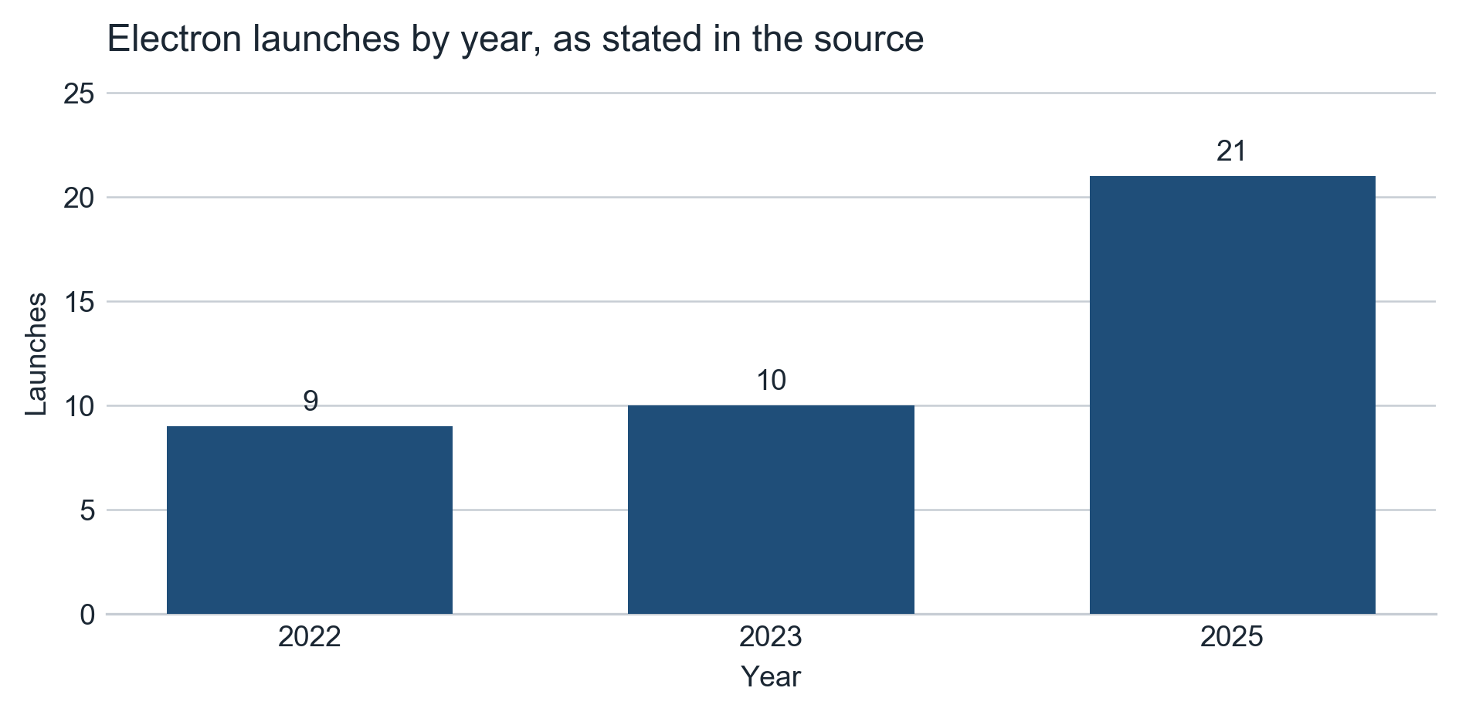
Chart of the annual launch counts stated in the source: 2022 - 9, 2023 - 10, 2025 - 21. The source lists no figure for 2024 and no bar is shown for that year; the gap is not a zero. These are observed launch counts, not a capacity estimate.
2025 21 Trend indicates increasing operational utilization , though current activity remains well below calculated infrastructure capacity.
Confidence: High

7. Operational Transparency and Observability
Operational activity is highly visible:
- Public launch announcements
- Live mission broadcasts
- Independent tracking by industry media and analytical communities
Given:
- small infrastructure footprint
- limited number of launch positions
- high public visibility
The existence of significant undisclosed operational capacity is assessed as unlikely .
Assessment
Operational activity is highly transparent; substantial discrepancies between actual and declared activity would likely be detected.
Confidence: High

8. System Capacity Model
Parameters:
- Launch pads: 2
- Sustainable turnaround: ~14 days

Calculation
≈ 26 launches per pad annually ≈ 52 launches per year theoretical sustainable maximum

Real-world adjustments
- production constraints
- weather and operational disruptions
- demand variability

Capacity Scenarios
Table 2. Capacity scenarios, as stated in the source
Scenario | Annual Launches
Conservative | 25-30
Most likely | 35-45
Maximum sustainable | 40-55

Figure 2. Capacity scenarios and highest observed annual total
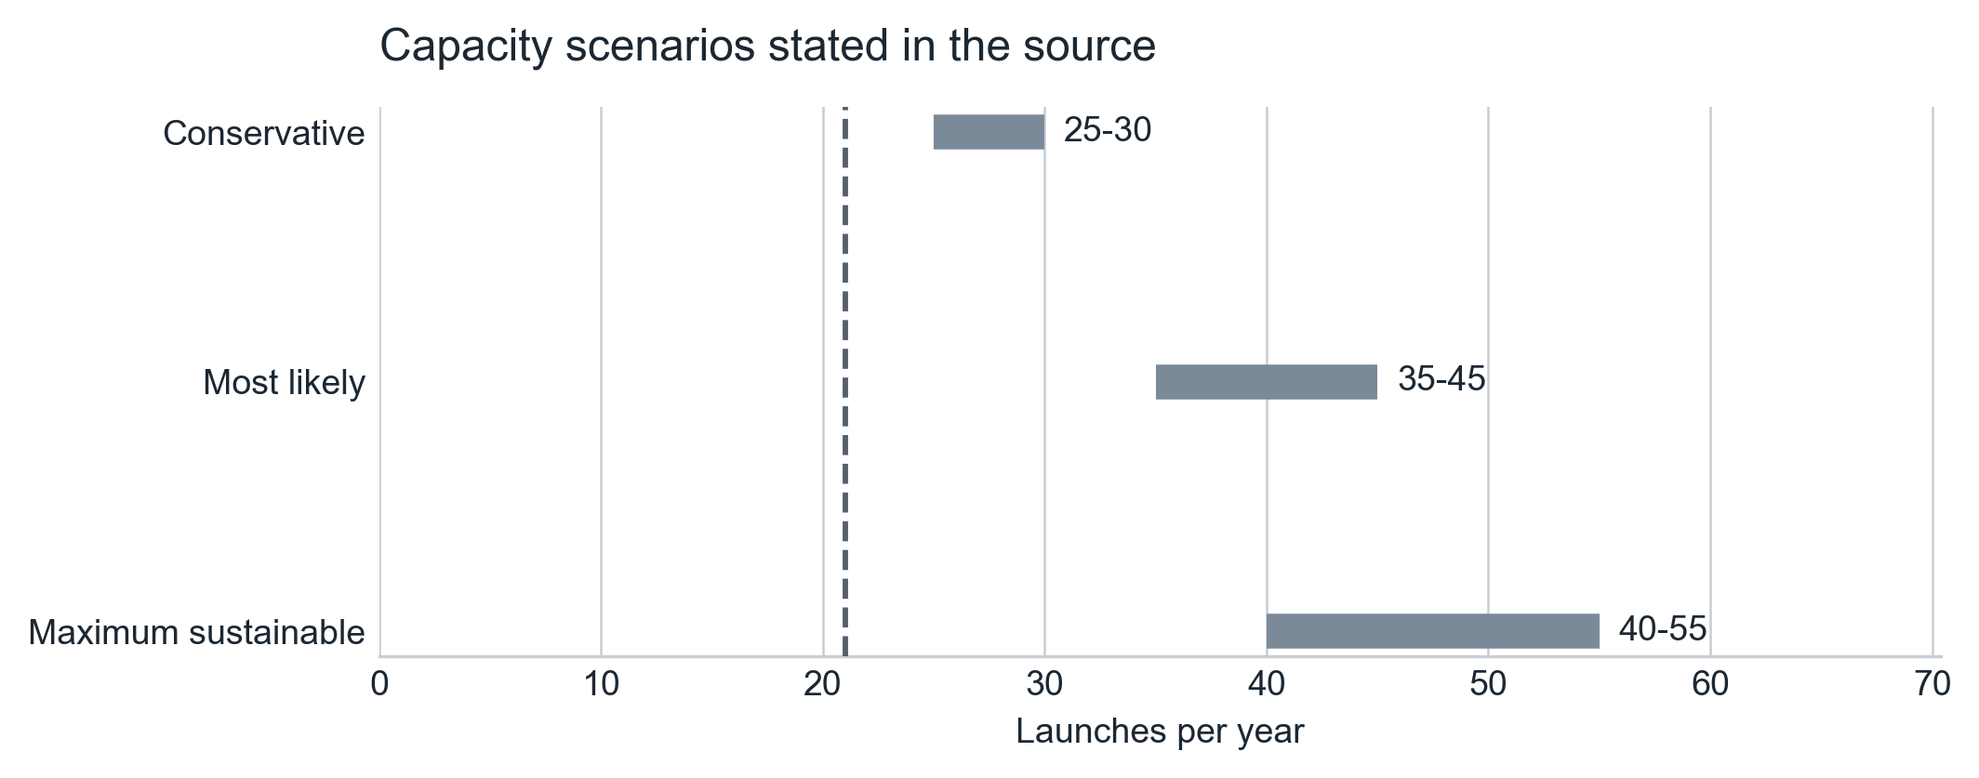
Range bars are the annual launch-count scenarios stated in the source: Conservative 25-30, Most likely 35-45, Maximum sustainable 40-55. The single marker is the source's highest observed annual total, 21 launches in 2025. The source states no figure for 2024. Bar extent is the stated range only; no midpoint or projection has been derived.

Risk Assessment
Table 3. Risk assessment, as stated in the source
Factor | Assessment | Confidence
Launch infrastructure bottleneck | Low | High
Production constraint | Moderate | Moderate
Weather/operational delays | Moderate | Moderate
Hidden capacity risk | Low | High

Final Assessment
Estimated maximum sustainable capacity: 40-55 launches per year
Primary limiting factor: Rocket production and delivery, not launch infrastructure.
Confidence: Moderate
TRANSPARENCY ASSESSMENT
Operational activity is highly observable; significant deviations from declared or observed utilization are unlikely to remain undetected.

System-Level Judgment
Launch Complex-1 represents a compact, centralized commercial spaceport optimized for high-frequency small-launch operations. The presence of two independent launch pads provides excess launch capacity relative to current utilization . Available evidence indicates that system throughput is constrained primarily by manufacturing scale and operational demand , rather than by launch site infrastructure. No observable indicators suggest hidden infrastructure or additional undisclosed launch capability.

Sources (Data Types)
- Commercial satellite imagery (Google Earth and equivalent platforms)
- Public launch records and mission timelines
- Rocket Lab official statements and investor materials
- Industry media and independent spaceflight tracking resources

Analytical Limitations
- No access to internal production or scheduling data
- Weather impacts not quantitatively modeled
- Customer backlog and demand dynamics not assessed

